 | 
COUNCIL ASSESSMENT REPORT
SYDNEY EASTERN CITY PLANNING PANEL

PANEL REFERENCE & DA NUMBER | PPSSEC-352 – DA376/2024/1
PROPOSAL | Demolition of the existing outdoor swimming pool of Scots College and construction of a new swimming pool and associated facilities including pool plant room, spectator seating and storage area.
ADDRESS | LOT: 1 DP: 231713 29-53 Victoria Road Bellevue Hill
APPLICANT | The Scots College
OWNER | The Presbyterian Church NSW Property
DA LODGEMENT DATE | 24/09/2024
APPLICATION TYPE | Integrated Development Application
REGIONALLY SIGNIFICANT CRITERIA | Section 2.19(1) and Clause 5 (b) of Schedule 6 of State Environmental Planning Policy (Planning Systems) 2021 declares the proposal regionally significant development as: Development that has an estimated development cost of more than $5 million for the purposes of an educational establishment.
CIV | $7,085,601.00
CLAUSE 4.6 REQUESTS | Nil
LIST OF ALL RELEVANT PLANNING CONTROLS (S4.15(1)(A) OF EP&A ACT) | State Environmental Planning Policy (Biodiversity and Conservation) 2021  State Environmental Planning Policy (Resilience and Hazards) 2021  State Environmental Planning Policy (Transport and Infrastructure) 2021  Woollahra Local Environmental Plan 2014  Woollahra Development Control Plan 2015
TOTAL & UNIQUE SUBMISSIONS | 3
KEY ISSUES | Nil
DOCUMENTS SUBMITTED FOR CONSIDERATION | Revised Acoustic Assessment report - E-Lab  Revised Architectural Plans – TKD Architects  Accessibility Report – DC Partnership  Aboriginal Cultural Heritage Impact Assessment Report – Urbis  Acoustic Assessment report - E-Lab  Arborists report – Temporal Tree Management  Civil Report and Plans – Taylor Thomson Whitting  Cost Estimate – Taylor & Partners Quantity Surveying  Geotechnical Site Investigation – Aargus Pty Ltd  Heritage impact statement – Urbis  Plan of management – Urbis  Preliminary Site Investigation – Aargus Pty Ltd  Structural DA Letter of Endorsement – Taylor Thomson Whitting  Structural Report/Construction Methodology – Northrop  Statement of Environmental Effects – Urbis  Survey plan –Rygate & Company Pty Ltd  Traffic Impact Assessment – JMT Consulting  Waste Management Plan – SLR Consulting Australia
DOCUMENTS SUBMITTED  WITH THIS REPORT FOR THE PANEL’S  CONSIDERATION | Annexure 1 - Draft Conditions  Annexure 2 - Revised Architectural Plans – TKD Architects  Annexure 3 – Referral Response Heritage  Annexure 4 – Referral Response Environmental Health  Annexure 5 –Referral Response Development Engineering  Annexure 6 – Referral Response Trees and landscaping
INFRASTRUCTURE CONTRIBUTIONS (S7.24) | N/A
RECOMMENDATION | Approval
DRAFT CONDITIONS TO APPLICANT | Yes
PLAN VERSION | Revision 2 04/11/2024  Revision 1 23/08/2024
PREPARED BY | Mr M D’Alessio
DATE OF REPORT | 26 March 2025

- REASON for report to local planning panel (LPP)

The application is to be determined by the Sydney Eastern City Planning Panel as it involves works to a community facility (educational establishment) with cost of works over $5 million (threshold under Clause 5 (b) of Schedule 6 of State Environmental Planning Policy (Planning Systems).

- REAsOns for recommendation

The application has been assessed within the framework of the matters for consideration under section 4.15 of the Environmental Planning and Assessment Act 1979 and is recommended for approval because:

- It is considered to be satisfactory with all relevant planning policies including the objectives of WLEP 2014 and WDCP 2015

- It will not have adverse effects on the local built and natural environment nor any adverse social and economic impacts in the locality

- All likely impacts to adjoining properties including any submissions made have been addressed in the report or are considered to be satisfactory.

- The site is suitable for the proposed development

- The proposal is in the public interest

- LOCALITY PLAN

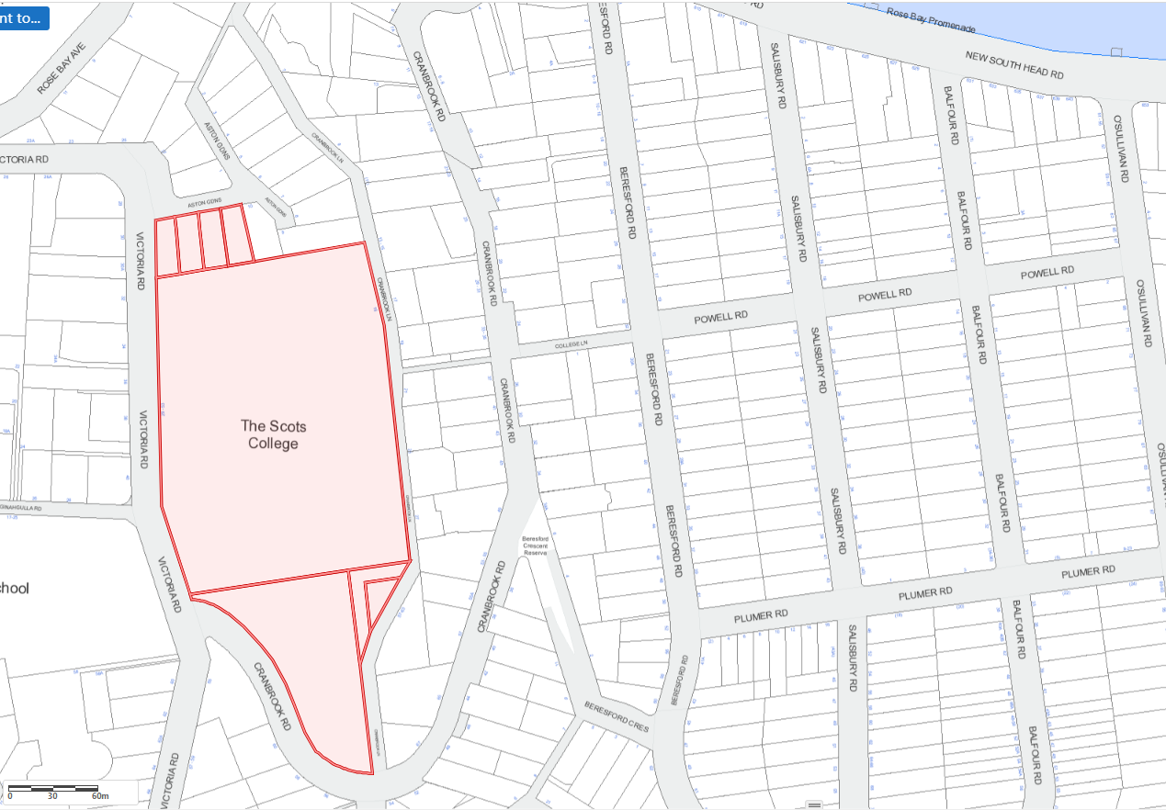
Subject site

Objectors
North

- PROPOSAL

The proposal seeks consent for the demolition of the existing outdoor pool and pool plant room, and the construction of a new outdoor pool with dimension of 25m x 30m x 2.2m in depth.

The new pool plant room will be built along the northern boundary of the site in the same location of the existing pool plant room. Additionally, new spectator seating and storage is proposed.

To support the pool a new backwash and balance tank is proposed along with a new OSD tank. The OSD tank will be located east of the pool under the concourse and a small patch of turf.

The key development data is provided in Table 1.

Table 1: Key Development Data
Control | Proposal
Site area | 44,710m²
GFA | Nil
FSR | N/A the site does not have a maximum floor space ratio control.
Clause 4.6 Requests | Nil
Max Height | 7.28m
Landscaped area and Tree Canopy Cover | Substantively maintained.
Car Parking spaces | Existing maintained.  60 on-site car parking spaces available. The Aston Gardens entrance leads to an underground car park.
Setbacks | Existing setbacks maintained

- ISSUES

None.

  - Exceptions to Development Standards in Woollahra Local Environmental Plan 2014

None.

  - Summary of Submissions

Issue | Conclusion | Section
Adverse amenity impacts including uncertainty in terms of proposed number of water polo games and hours of use | The proposal is supported by a Plan of Management and revised Acoustic Report that form part of the recommended approval documents that adequately specify the proposed use of the pool facility.  The proposal does not seek to alter or intensify the use of the pool and will not result in any significant adverse amenity impacts upon adjoining properties as recommended to be determined. | 12, 13, 14 and recommended approval conditions
Adverse traffic impacts:  - Ongoing use of the pool  - Adverse construction related traffic and parking impacts to Aston Gardens associated with the use of the site’s Aston Gardens driveway access as specified in the submitted Structural Report/Construction Methodology report prepared by Northrop.  - Submission that all construction related access be limited to the Cranbrook Lane driveway located near the oval entrance of the site as specified in the submitted Traffic Impact Assessment prepared by JMT Consulting. | The proposal does not result in demand for additional car parking, users will continue to make use of the existing parking facilities available on the school grounds.  The issues raised in terms of adverse construction related traffic and parking impacts can be resolved through conditions including:  - Condition B.14 - The submission of a Construction Traffic Management Plan (CTMP) to Council for approval prior to commencement of demolition works. | 12, 13, 14 and recommended approval conditions

PROPERTY DETAILS AND REFERRALS

- SITE AND LOCALITY

Physical features
The subject site forms part of the Victoria Road east precinct of the College at 29-53 Victoria Road, Bellevue Hill. The site is bounded by Victoria Road to the west, Cranbrook Lane to the east, Cranbrook Road to the south, and Aston Gardens to the north.
Topography
The proposed development area is relatively flat. However, where the pool plant room is located has a significant fall to the neighbouring property to the north. Additionally, the part of the school site to the north of the pool has some significant level change as you move up towards Victoria Road.
Existing buildings and structures
The site has a variety of landscaping and trees across the campus. More specifically, the pool area contains a mostly cement setting with scattered grass. Additionally, a number of trees are located around the pool.

Pedestrian access to the broader site is via Victoria Road, Cranbrook Lane and Cranbrook Road. Vehicles can access the site via Victoria Road and Aston Gardens. The Aston Gardens entrance leads to an underground car park.
Surrounding Environment
The local area is characterised by a mixture of development types including low and medium density residential, educational establishments (schools) and public recreation.

The subject site is located in the Bellevue Hill North precinct. Part B1.8 of the Woollahra DCP 2015 provides the following precinct character statement:

The Bellevue Hill North precinct is sited on the slopes and plateau of Bellevue Hill. New South Head Road, the main arterial road, forms the northern edge of the precinct. The precinct contains three distinct settings:
- the edge development fronting New South Head Road (between Bellevue Road and Victoria Road) which contains predominantly substantial residential flat buildings set behind sandstone walls, garages and steps;
- development opposite the Rose Bay promenade on New South Head Road, typically large detached buildings within a landscape setting; and
- the one to three storey dwelling houses and residential flat buildings set in the winding streets that follow the contours of Bellevue Hill. As with many of the higher parts of the municipality, significant views and vistas are available from many of the public spaces.

As with many of the higher parts of the municipality, significant views and vistas are available from many of the public spaces. This precinct also contains two large private school campuses: Cranbrook School and Scots College.

Fig. Existing pool facing south | Fig. Existing pool facing east
Fig. Existing shade cloth | Fig. Existing underground plant room

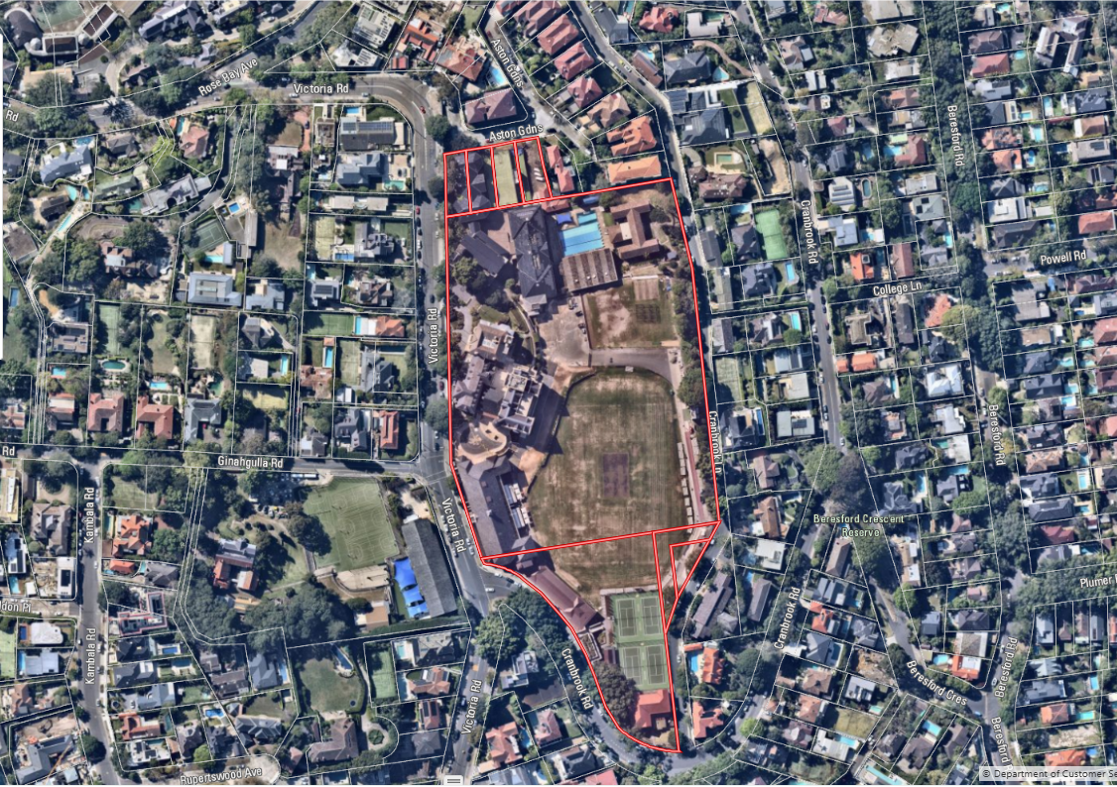

- RELEVANT PROPERTY HISTORY

Current use
Educational Establishment (The Scots College)
Relevant Application History
- DA390/2019/1 Ancillary Structure/Landscaping: The demolition of existing tennis courts at The Scots College, excavation to create underground car parking and associated facilities with new tennis courts above, a new (re-located) entry from Cranbrook Lane, and an increase in the approved student numbers from 1,120 to 1,520, approved 12/04/2023
- DA171/2019/2 Section 4.55 Modifications to the approved alterations and additions to the Assembly Hall approved 12/06/2020
- DA171/2019/1 Educational Establishment: Alterations and additions to the Assembly Hall (and associated works) on the upper level of the Main School building approved 07/11/2019

Requests for Additional Information and Replacement Applications
- 9/10/2024 - Request for Information from Council to applicant:
      - Details of Proposed Construction Methodology Involving Excavation and Structural Report / Owners consent from Adjoining Properties,
      - Arboricultural Impact Assessment Report and Tree Protection Plan; and
      - Aboriginal Heritage Impact Assessment.

This information was submitted on 13/11/2025.

- 28/02/2025 - Request for Information from Council to applicant:

      - Addendum or revision to the Acoustic Assessment report prepared by E-Lab in terms of the noise assessment contained to conform with the existing/proposed swimming pool use hours of 6am - 6pm and student and spectator numbers to include 50 to 100 people attending weekend matches for consistency with the submitted Statement of Environmental Effects, Plan of Management and Traffic Impact Assessment.

On 03/03/2025 the Applicant submitted a revised Acoustic Assessment report detailing hours of the swimming pool use to be 7am – 6pm with 50-100 users.

- REFERRALS

Referral | Summary of Referral Response | Annexure
Heritage | Council’s Heritage Officer reviewed the proposal in terms of Heritage items and buildings, works, relics or trees and potential Aboriginal Heritage Sensitivity and supports the proposal subject to conditions of consent. | 3
Health | Council’s Environmental Health Officer reviewed the proposal in terms of acoustic impacts, land contamination and acid sulfate soils and supports the proposal subject to conditions of consent. | 4
Engineering | Council’s Development Engineer reviewed the proposal in terms of site drainage, stormwater, flooding and overland flow, impacts on Council infrastructure, geotechnical, hydrogeological and structural impacts and supports the proposal subject to conditions of consent. | 5
Trees and Landscaping | Council’s Tree and Landscape officer reviewed the proposal in terms of trees, tree canopy cover and landscaping and supports the proposal subject to conditions of consent. | 6

ENVIRONMENTAL ASSESSMENT UNDER SECTION 4.15

The relevant matters for consideration under Section 4.15 of the Environmental Planning and Assessment Act 1979 include the following:

- The provisions of any environmental planning instrument
- The provisions of any proposed instrument that is or has been the subject of public consultation under this Act and that has been notified to the consent authority (unless the Planning Secretary has notified the consent authority that the making of the proposed instrument has been deferred indefinitely or has not been approved)
- The provisions of any development control plan
- The provisions of any planning agreement that has been entered into under section 7.4, or any draft planning agreement that a developer has offered to enter into under section 7.4
- The provisions of the regulations (to the extent that they prescribe matters for the purposes of this paragraph)
- The likely impacts of that development, including environmental impacts on both the natural and built environments, and social and economic impacts in the locality
- The suitability of the site for the development
- Any submissions made in accordance with this Act or the regulations
- The public interest

- ADVERTISING AND NOTIFICATION

  - Submissions

The application was advertised and notified from 16 October 2024 to 31 October 2024 in accordance with Chapter 6 of the Woollahra Community Participation Plan. Three (3) submissions were received from:

- Wre & Jb Ell 11 Cranbrook Lane, Bellevue Hill, NSW 2023
- Alldis & Cox Pty Ltd obo The Owners - Strata Plan No. 1485 - 8 Aston Gardens Bellevue Hill
- George Kminiak obo The Owners - Strata Plan No. 102478 - 6 Aston Gardens Bellevue Hill

The issues raised in the submissions have been summarised in Section 5.2 and considered throughout the report.

  - Statutory Declaration

The applicant has completed a statutory declaration dated 1 November 2024 declaring that the site notice for DA376/2024/1 was erected and maintained during the notification period in accordance with the Woollahra Community Participation Plan.

- STATE ENVIRONMENTAL PLANNING POLICY (BIODIVERSITY AND CONSERVATION) 2021

Chapter 2 Vegetation in non-rural areas

Clause 2.9(1) defers assessment to the appropriate development control plan in determining vegetation to which Chapter 2 applies. Accordingly, Chapter E3 Tree Management under WDCP 2015 is applicable.

Council’s Trees and Landscape Officer considers that the proposal is satisfactory, regarding the relevant provisions of Chapter 2 of State Environmental Planning Policy (Biodiversity and Conservation) 2021.

Chapter 6 Water Catchments

Chapter 6 of the Biodiversity and Conservation SEPP applies to the subject land. The subject land is within the Sydney Harbour Catchment, but is outside the Foreshores and Waterways Area. Therefore, only the provisions in Part 6.2 of the SEPP apply to the proposal. In deciding whether to grant development consent to development on land in a regulated catchment, matters relating to water quality and quantity, aquatic ecology, flooding, recreation and public access, and total catchment management must be considered.

The proposal will have no significantly adverse impacts on the Sydney Harbour Catchment, subject to Council’s standard conditions including erosion and sedimentation, stormwater and flood risk management control.

The proposal does not contravene the relevant general requirements under Part 6.2 of the State Environmental Planning Policy (Biodiversity and Conservation) 2021.

- STATE ENVIRONMENTAL PLANNING POLICY (RESILIENCE AND HAZARDS) 2021

Chapter 2 Coastal Management

The provisions of this chapter that are relevant to the subject application involve managing development in the coastal zone and protecting the environmental assets of the coast.
It is considered that the proposal, as conditioned, will not have any significant adverse environmental impact upon the harbour coastal locality and therefore satisfactory with regard to the relevant provisions of the Chapter 2 of SEPP (Resilience and Hazards) 2021.

Chapter 4 Remediation of Land

Clause 4.6(1) (a) of SEPP (Resilience and Hazards) 2021, requires consideration to be given as to whether the subject land is contaminated. The application maintains the existing residential land use of the subject land, the site is not within an investigation area.

Consideration with respect to Clause 4.6(a) of Chapter 4 has been given as to whether the subject site on which the development is occurring is contaminated.

A preliminary site investigation (PSI) has been undertaken by Aargus. Council’s Environmental Health Officer has confirmed that Clause 4.6 of the State Environmental Planning Policy (Resilience and Hazards) 2021 is satisfied, in that the site is suitable for the proposed construction of a new swimming pool development.

Any soils requiring removal from the site, as part of future site works, should be classified in accordance with the “Waste Classification Guidelines, Part 1: Classifying Waste” NSW EPA
(2014).

- STATE ENVIRONMENTAL PLANNING POLICY (Transport and Infrastructure) 2021

  - Chapter 3: Educational Establishments

12.1.1 Part 3.4 Schools—specific development controls

Section 3.36 Schools—development permitted with consent

The proposal is defined as an educational establishment (school) and is permissible by virtue of State Environmental Planning Policy (Transport and Infrastructure) 2021. Pursuant to Clause 3.36(1) of the SEPP a school is permitted with consent on the subject site as it is an SP2 prescribed zone.

Subsection (6) of Section 3.36 specifies:

(6) Before determining a development application for development of a kind referred to in subsection (1), (3) or (5), the consent authority must take into consideration—
(a) the design quality of the development when evaluated in accordance with the design quality principles set out in Schedule 8, and
(b) whether the development enables the use of school facilities (including recreational facilities) to be shared with the community.

It is not proposed to intensify the use of the pool for community use. The design of the pool and associated facilities accord with the design quality principles set out in Schedule 8 Design quality principles in schools as follows:

1 Responsive to context
2 Sustainable, efficient and resilient
3 Accessible and inclusive
4 Healthy and safe
5 Functional and comfortable
6 Flexible and adaptable
7 Visual appeal

A detailed assessment against schedule 8 of the State Environmental Planning Policy (Transport and Infrastructure) 2021 is provided below:

Schedule 8 Design quality principles in schools—Chapter 3

1 Responsive to context

- Schools should be designed to respond to and enhance the positive qualities of their surroundings.
- In designing built forms and landscapes, consideration should be given to a Country-centred approach and respond to site conditions such as orientation, topography, natural systems, Aboriginal and European cultural heritage and the impacts of climate change.
- Landscapes should be integrated into the overall design to improve amenity and to help mitigate negative impacts on the streetscape and neighbouring sites.
The proposal accords with the design principal, including that:

- The pool is a replacement pool in an established pool location (more than 40 years old) that accords with the existing campus layout.
- The updated facility will improve the use and amenity of the outdoor pool area for students.
- Proposed landscaping accords with established landscape treatment and assists to improve amenity impacts to the streetscape and neighbouring sites.

2 Sustainable, efficient and resilient

- Good school design combines positive environmental, social and economic outcomes and should align with the principles of caring for Country.
- Schools should be designed to be durable and resilient in an evolving climate.
- Schools and their grounds should be designed to minimise the consumption of energy, water and other natural resources and reduce waste.

The proposal accords with the design principal, including that:

- The proposal is a replacement of the existing pool.
- A new pool plant room with updated systems will increase the efficiently of the filtration system.

3 Accessible and inclusive

- School buildings and grounds should be welcoming, easy to navigate and accessible and inclusive for people with differing needs and abilities.
- Schools should be designed to respond to the needs of children of different ages and developmental stages, foster a sense of belonging and seek to reflect the cultural diversity of the student body and community.
- Schools should be designed to enable sharing of facilities with the community and to cater for activities outside of school hours.
The proposal accords with the design principal, including that:

- The pool is currently accessible through the school and a pool lift will be made available for equitable access into the pool.

4 Healthy and safe

- Good school design should support wellbeing by creating healthy internal and external environments.
- The design should ensure safety and security within the school boundaries, while maintaining a welcoming address and accessible environment.
- In designing schools, consideration should be given to connections, transport networks and safe routes for travel to and from school.
The proposal accords with the design principal, including that:

- The pool is a replacement pool in an established pool location, the proposal is considered acceptable in terms of and health and safety design considerations.
- The pools plant will be replaced which will improve the health and safety of those using the pool and plant room.

5 Functional and comfortable

- Schools should have comfortable and engaging spaces that are accessible for a wide range of formal and informal educational and community activities.
- In designing schools, consideration should be given to the amenity of adjacent development, access to sunlight, natural ventilation, proximity to vegetation and landscape, outlook and visual and acoustic privacy.
- Schools should include appropriate indoor and outdoor learning and play spaces, access to services and adequate storage.
The proposal accords with the design principal, including that:

- As recommended to be determined the proposed replacement pool improves the comfort and functioning of the school including provision of spectator seating without adversely impacting on the amenity of adjacent development.

6 Flexible and adaptable

- In designing schools, consideration should be given to future needs and take a long-term approach that is informed by site-wide strategic and spatial planning.
- Good design for schools should deliver high environmental performance and ease of adaptation, and maximise multi-use facilities.
- Schools should be adaptable to evolving teaching methods, future growth and changes in climate, and should minimise the environmental impact of the school across its life cycle.
The proposal accords with the design principal, including that:

- The pool location is appropriate and established in the campus, the design will allow flexibility in the use for both water polo and lap swimming.

7 Visual appeal

- School buildings and their landscape settings should be aesthetically pleasing by achieving good proportions and a balanced composition of built and natural elements.
- Schools should be designed to respond to and have a positive impact on streetscape amenity and the quality and character of the neighbourhood.
- The identity and street presence of schools should respond to the existing or desired future character of their locations.
- The design of schools should reflect the school’s civic role and community significance.
The proposal accords with the design principal, including that:

- The new outdoor pool and spectator seating will maintain the sporting aesthetics of the area.
- The new spectator seating will have a similar colour palette to the surrounding buildings.

- WOOLLAHRA LOCAL ENVIRONMENTAL PLAN 2014

  - Clause 1.2: Aims of Plan

The proposal is consistent with the aims in Clause 1.2(2) of the Woollahra LEP 2014.

  - Land Use Table

The proposal is defined as alterations and additions to an existing educational establishment and is consistent with the objectives of the SP2 Infrastructure zone as follows:

- To provide for infrastructure and related uses.
- To prevent development that is not compatible with or that may detract from the provision of infrastructure.
- To encourage the retention and planting of trees and other vegetation as part of development to minimise the urban heat island effect and to improve microclimates.
In terms of permissibility the subject site is in a SP2 Infrastructure zone which is a prescribed zone for an educational establishment under clause 3.36 (1) of Part 3.4 Schools—specific development controls of the State Environmental Planning Policy (Transport and Infrastructure) 2021.

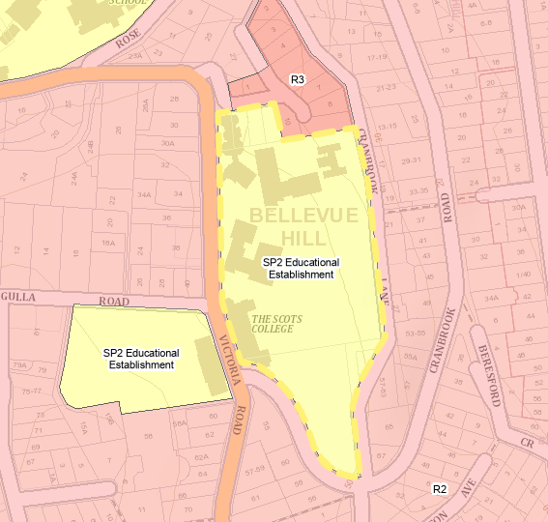
Fig. Zoning map – WLEP 2014 (Source: NSW Planning Portal Spatial Viewer).

  - Clause 4.3: Height of Buildings

Clause 4.3(2) limits development to a maximum height of 9.5m.

 | Proposed | Control | Complies
Maximum Building Height | 7.28m  RL51.36 - RL44.08 | 9.5m | Yes

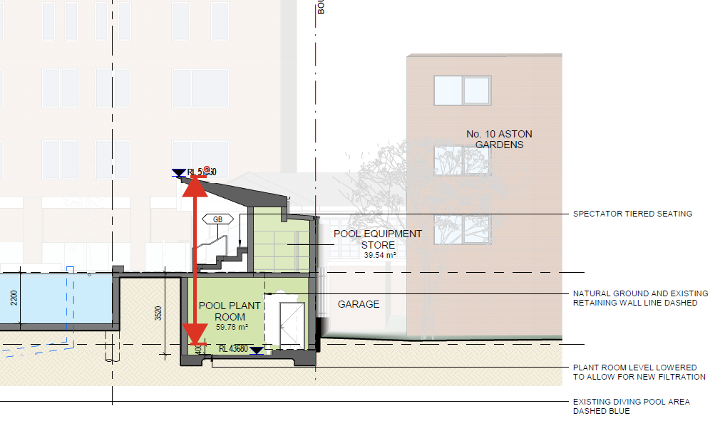
Fig. Maximum building height

The proposal complies with the maximum building height prescribed by Clause 4.3 (2) and is acceptable with regard to the relevant objectives under Clause 4.3(1) of Woollahra LEP 2014.

  - Clause 4.4: Floor Space Ratio

There is no applicable FSR control.

  - Clause 5.10: Heritage Conservation

The Clause 5.10 (1) objectives for heritage conservation are as follows:

(a) to conserve the environmental heritage of Woollahra,
(b) to conserve the heritage significance of heritage items and heritage conservation areas, including associated fabric, settings and views,
(c) to conserve archaeological sites,
(d) to conserve Aboriginal objects and Aboriginal places of heritage significance.

Heritage items and buildings, works, relics or trees within a heritage conservation area

The subject site includes the heritage listed The Scots College—the building known as “Aspinall House” and interiors, with palm trees, sandstone gateposts (3 sets), gate and fencing to Victoria Road, and the adjoining stone wall surmounted by iron railing; the school building with clock-tower and interiors listed and described in Schedule 5 Part 1 of Woollahra Local
Environment Plan 2014 as follows:

Suburb | Item name | Address | Property description | Significance | Item no
Bellevue Hill | The Scots College—the building known as “Aspinall House” and interiors, with palm trees, sandstone gateposts (3 sets), gate and fencing to Victoria Road, and the adjoining stone wall surmounted by iron railing; the school building with clock-tower and interiors | 29–53 Victoria Road | Lots 10–13, DP 14952; Lot 1, DP 231713; Lot 1, DP 929570; Lot 1, DP 663629; Lot 1, DP 1064059 | Local | I67

The following Statement of Significance for each of the above items is taken from the State Heritage Inventory.

The Scots College (I67)

The Scots College is of cultural significance as an example of a private, boys’ secondary school that was opened on the site by the Scots College in 1895 in the house St. Killians that they had leased in the same year to allow for the relocation from Brighton-le-Sands.

The site was comprehensively developed from 1914 onwards when a series of purpose-designed buildings were constructed including the Middle School (1915). MacIntyre House (1919), Kirkland House (1926) and the Memorial Chapel/Anderson Hall (1956)
The place is strongly associated with the Presbyterian Church that purchased the leasehold of the site in 1907 and that was instrumental in the establishment of the original school in 1893.

The College retains a number of significant, high quality, architect-designed buildings including Aspinall House (formerly St. Killians) (Mansfield Brothers), Middle School and MacIntyre House (Power and Adams), Kirkland House (Morrow Deputron and Gordon) and the Memorial Chapel/Anderson Hall (Frederick Glynn Gilling).

The place has operated as a school since 1895 and would have social significance for the Presbyterian Church that was instrumental in the establishment of the College, the thousands of pupils that have passed through its halls and their families and the numerous staff who have worked there. The school provides a social focus for the local community and continues to provide high quality, secondary education for boys.
(Source: John Oultram Heritage & Design, 2019)

The subject site is located adjacent the Aston Gardens Heritage Conservation Area, described in Schedule 5 Part 2 of Woollahra Local Environment Plan 2014 as follows:

Suburb | Name of heritage conservation area | Significance | Item no
Bellevue Hill | Aston Gardens | Local | C1

Aston Gardens Heritage Conservation Area (C1)

The Aston Gardens HCA is an outstanding group of significant Inter-War flat buildings designed by prominent architects that remain largely intact in their fabric, 1927 subdivision pattern and garden settings. Aston Gardens is rare in that nearly every architectural style of the Inter-War period is represented in the one street. Many of the flats are large and many originally included servant’s quarters. The area is significant in demonstrating the move away from large freestanding houses to modern and fashionable flats during the Inter-War period and the changing planning regulations increasing the density of the inner suburbs of Sydney.

The Inter-War flat buildings are 2 to 4 storeys in height, in Spanish Mission, Georgian Revival and Art Deco styles in a landscaped garden setting. The intact subdivision occupies the north-east facing slope that falls steeply away from Victoria Road. The buildings are constructed of face brick or rendered brick with generally timber double hung windows (some with timber shutters) and generally hipped and gabled roof forms with terra cotta roof tiles. The facades feature decorative render/plasterwork, and/or brick detailing.

The subject site is located in proximity to the following Heritage Items, described in Schedule 5 Part 1 of Woollahra Local Environment Plan 2014 as follows:

Suburb | Item name | Address | Property description | Significance | Item no
Bellevue Hill | “St. Clair”—house and interiors | 13–15 Cranbrook Lane | Lot 1, DP 569290 | Local | I18
Bellevue Hill | Norfolk Island Pine | 21–23 Cranbrook Road | Lot 1, DP 127457; Lot 1, DP 926402 | Local | I17

Significance of the area of proposed works

Council’s Heritage Officer supports the proposal and has advised that they concur with the assessment of significance provided in the Statement of Heritage Impact in support of the proposal which assesses the pool in accordance with the Heritage NSW guidelines as follows:

- The current pool is a late Twentieth Century sports facility that was completed in 1972 (along with the adjoining gymnasium) to the design of architects Budden, Nangle & Michael. The practice also designed the Stevenson Library in 1986 in a brutalist design that is currently being remodeled.
- The pool is a modern element and, by its nature is quite utilitarian and is of low significance.

Aboriginal Object or Place

The subject site is identified as potentially Aboriginal Heritage Sensitive land.

Condition’s of consent to cover Aboriginal Heritage Induction, Aboriginal Heritage Due Diligence Responsibilities, site induction, Aboriginal Heritage Due Diligence Responsibilities are included in the recommended conditions of consent as advised by Council’s Heritage Officer as part of the initial assessment of the application.

Councils Heritage Officer has provided the following summarised assessment under Clause 5.10:

- Clause 5.10(1)(a) and (b): The proposed development conserves the heritage of Woollahra as it would not give rise to unacceptable impact on the heritage significance of the item and its setting, including views to and within the item, and the broader visual catchment.
- Clause 5.10(2) and (3): Consent is required for the proposed works
- Clause 5.10(4): This referral constitutes an assessment under this clause. The effect of the proposal on the heritage significance of the item has been considered and the proposal is found to be acceptable on heritage grounds.
- Clause 5.10(5): A heritage management document was submitted with the development application and was found to be acceptable.
- Clause 5.10(6): A Conservation Management Plan was not required
- Clause 5.10(7) and (8): The site is not identified as an archaeological site or a place of Aboriginal heritage significance. A referral was sent to the La Perouse Local Aboriginal Land Council on 6 November 2024 and no return correspondence was received within 28 days.
- Clause 5.10(9): Demolition of a nominated State heritage item is not proposed.
- Clause 5.10(10): Conservation incentives are not being sought as part of this application.

Accordingly, the proposal is acceptable with regard to the objectives in Clause 5.10 of the Woollahra LEP 2014.

  - Clause 5.21: Flood Planning

The objectives of Clause 5.21 are:

- to minimise the flood risk to life and property associated with the use of land,
- to allow development on land that is compatible with the flood function and behaviour on the land, taking into account projected changes as a result of climate change,
- to avoid adverse or cumulative impacts on flood behaviour and the environment,
- to enable the safe occupation and efficient evacuation of people in the event of a flood.

The subject site is located in the Bellevue Hill Sub Catchment of the Rose Bay Flood Study Area.

Council’s Drainage Engineer has reviewed the proposal and determined that the proposal is satisfactory in terms of Clause 5.21 with no specific flood related conditions being required.

The proposal is considered to be satisfactory with regard to the provisions of Clause 5.21 of Woollahra LEP 2014.

  - Clause 6.1: Acid Sulfate Soils

Clause 6.1 requires Council to consider any potential acid sulfate soil affectation so that it does not disturb, expose or drain acid sulfate soils and cause environmental damage.

The subject site is within a Class 5 area as specified in the Acid Sulfate Soils Map. However, the subject works are not likely to lower the water table below 1.0m AHD on any land within 500m of a Class 1, 2 and 3 land classifications. Accordingly, preliminary assessment is not required and there is unlikely to be any acid sulfate affectation. It is therefore acceptable with regard to Part 6.1.

  - Clause 6.2: Earthworks

Clause 6.2(1) requires Council to ensure that any earthworks will not have a detrimental impact on environmental functions and processes, neighbouring uses, cultural or heritage items or features of the surrounding land.

Excavation works are required as part of the proposal. The application is supported by a Geotechnical Investigation Report.

The proposed excavation works have been reviewed and considered by Council’s technical experts as follows:

- Council’s Development Engineer considers the proposed earthworks to be satisfactory in terms of geotechnical/ hydrogeological issues, subject to conditions;
- Council’s Heritage Officer raised no objection on the basis of any archaeological considerations, subject to conditions;
- Council’s Trees Officer has raised no objection on the basis of detrimental impacts to existing significant trees or vegetation, subject to conditions.

The proposal is acceptable with regard to the relevant objectives in Clause 6.2 of the Woollahra LEP 2014.

- WOOLLAHRA DEVELOPMENT CONTROL PLAN 2015

  - Chapter B1: Residential Precincts

    - Part B1: Bellevue Hill North Residential Precinct

The proposal meets the streetscape character and key elements of the precinct and desired future character objectives of the Bellevue Hill North Residential Precinct, as noted in Part B1.8.2 of the Woollahra DCP 2015.

  - Chapter B3: General Development Controls

    - Part B3.4 Excavation

Site Area: 44,610m² | Proposed | Control | Complies
C1 B3.4 Maximum Volume of Excavation | SEE specifies:  Minimal  SWMMP specifies approximately 23m³ | 44,610m³ | Yes
C9 B3.4 Geotechnical Report | Geotechnical Report submitted | Required where  > 2.0m or within 1.5m of the boundary | Yes

O1 To set maximum acceptable volumes of excavation which:
  - require buildings to be designed and sited to relate to the existing topography of the site;
  - ensure excavation, including the cumulative impacts of excavation, does not adversely impact land stabilisation, ground water flows and vegetation;
  - avoid structural risks to surrounding structures;
  - ensure noise, vibration, dust and other amenity impacts to surrounding properties during construction are reasonable;
  - enable deep soil planting in required setbacks;
  - ensure traffic impacts and impacts on local infrastructure arising from the transfer of excavated material from the development site by heavy vehicles are reasonable; and
  - satisfy the principles of ecologically sustainable development (including the energy expended in excavation and transport of material and the relative energy intensity of subterranean areas in dwellings).

C3 For any other use (including attached and detached garaging) not addressed in C1 and C2 above—the maximum volume of excavation permitted is no greater than the volume shown in Figure 13B.

C10 Excavation below 2m or within 1.5m of the boundary must be accompanied by a geotechnical and hydrogeological report and a structural report demonstrating that the works will not have any adverse effect on surrounding structures.

The proposal is compliant in terms of the maximum volume of excavation controls under C1 and is supported by a Geotechnical Investigation Report in accordance with C10.

The proposed excavation works have been reviewed and considered by Council’s technical experts as follows:

- Council’s Development Engineer considers the proposed earthworks to be satisfactory in terms of geotechnical/ hydrogeological issues, subject to conditions
- Council’s Heritage Officer raised no objection on the basis of any archaeological considerations, subject to conditions.
- Council’s Trees Officer has raised no objection on the basis of detrimental impacts to existing significant trees or vegetation, subject to conditions.

The proposal is accordant with the applicable objectives and controls:

- O1, C3 and C10 (excavation controls)

    - Part B3.5.1: Streetscape and Local Character

Part B3.5.1: Streetscape and Local Character

The proposal would not give rise to adverse streetscape impacts and is compatible with the desired future character of the Bellevue Hill North Residential Area and adjacent Aston Gardens Heritage Conservation Area.

The proposal is compliant in terms of the applicable objectives and controls:

- O1, O2, O3, O4, C1, C3, C4, C5, C6, C7 and C8 (streetscape character)
- O5, C8 and C9 (roof forms)

Part B3.5.2: Overshadowing

The proposal would maintain compliant solar access to adjoining main ground level private open space and north facing upper-level habitable room windows of adjacent dwellings between 9am and 3pm on 21 June in accordance with C1.

The proposal is compliant in terms of the applicable objectives and controls:

- O1, C1, C2 (overshadowing to adjoining properties)

Part B3.5.3: Public and Private Views

The proposal does not result in increases to building bulk and scale or new tree plantings that would give rise to any significant adverse impacts to private or public views.

The proposal is compliant in terms of the applicable objectives and controls:

- O1, O2, Cl, C2, C3 and C4 (public views and vistas)
- O3, C5, C6 and C7 (private views – view sharing)
- O4, C9 and C10 (landscaping)

Part B3.5.4: Acoustic and Visual Privacy

O1 To ensure adequate acoustic privacy for occupants and neighbours.
C3 Electrical, mechanical, hydraulic and air conditioning equipment is housed so that it does not create an ‘offensive noise’ as defined in the Protection of the Environment Operations Act 1997 either within or at the boundaries of any property at any time of the day.

The proposal is supported by a Plan of Management and Acoustic Report that form part of the recommended approval documents.

The proposal which does not seek to alter or intensify the use of the pool, will not result in any significant acoustic privacy impacts upon adjoining properties subject to the imposition of Council’s standard conditions relating to the control of offensive noise if the recommendation was for approval.

The proposed is accords with the relevant objective and controls:

- O1, C1 and C3 (adequate acoustic privacy)

    - Part B3.7: External Areas

O1 To ensure that the areas outside the building contribute to the desired future character of the location.
O2 To provide sufficient deep soil landscaped area to encourage urban greening and maintain and enhance tree canopy cover which in turn contributes positively to the existing and desired future character of the locality.
O3 To provide for on-site stormwater absorption.

C2 35% of the site area is deep soil landscaped area with the exception of the Wolseley Road area (Figure 22) where 30% of the site area is deep soil landscaped area. Refer Figure 21 for the calculation of deep soil landscaped area.

Subject to conditions, Council’s Trees Officer supports the removal and replacement planting.

The subject site contains substantive areas of open space including 2 x ovals/playing fields, tennis and basketball courts, as well as landscaped areas.

Additional consideration of the Educational Establishment - Open Space and planting controls is included under Parts F2.5 and F2.7 of the Woollahra DCP 2015.

    - Part B3.8: Additional Controls for Development Other Than Dwelling Houses

  - Chapter E1: Parking and Access

The proposal does not result in demand for additional car parking, users will continue to make use of the existing parking facilities available on the school grounds.

The proposal is satisfactory with regard to the parking and access objectives and controls in Chapter E1 of the Woollahra DCP 2015.

Additional consideration of the Educational Establishment - Traffic, parking and access controls is included in the assessment of Part F2.6 of the Woollahra DCP 2015 in this report.

  - Chapter E2: Stormwater and Flood Risk Management

Council’s Development Engineer and Council’s Drainage Engineer have reviewed the proposal and advised that subject to conditions of development consent the proposal is acceptable with regard Chapter E2 of the Woollahra DCP 2015.

  - Chapter E3: Tree Management

The proposal is acceptable with regard to Chapter E3 of the Woollahra DCP 2015.

  - Chapter E5: Waste Management

Chapter E5 is applicable to all development and seeks to establish waste minimisation and sustainable waste management during demolition and construction phases and throughout the on-going use of the building.

The SWMMP addresses volume and type of waste and recyclables to be generated, storage and treatment of waste and recyclables on site, disposal of residual waste and recyclables and operational procedures for ongoing waste management once the development is complete.

The applicant provided a Waste Management Plan with the development application and it was found to be satisfactory.

  - Chapter E6: Sustainability

14.7.1 Part E6.2: Commercial and Non-Residential Buildings

O5 To reduce water consumption and encourage on-site water retention and re-use.

O6 To encourage tree selection that reduces the need for artificial heating and cooling of buildings.
C12 Subject to view impacts to adjoining properties, wide canopied deciduous trees are planted to the north of buildings to provide shade during warmer months and allow sunlight penetration during cooler months.
C13 Subject to view impacts to adjoining properties, evergreen trees are planted to the west and east of buildings to prevent glare and heat during warmer months.

In accordance with the applicable C12 and C13, the proposed replacement planting located to the east of the adjacent TM Scott Building and central quadrangle of the school will prevent glare and heat during warmer months.

The proposal will retain the existing stormwater system with an additional OSD tank provided under part of the concourse to comply with the Development Control Plan (DCP).

The proposal is acceptable with regard to the non-residential building objectives and controls in Chapter E6 of the Woollahra DCP 2015.

  - Chapter F2: Educational Establishments

    - 14.8.2 Part F2.2: Building and Urban Design

O1 To encourage well designed buildings.
O2 To encourage buildings that positively contribute to the streetscape and character of the location.
O3 To encourage sustainable design.

C1 Development incorporates a high standard of architectural design, materials and detailing appropriate to the building type and location.
C3 Development on the boundary provides a sympathetic transition in terms of height, scale, bulk and materials.

The proposal is well considered in terms of the new pool, spectator seating, plant and pool storage areas designed to integrated into the existing campus.

The siting, height, bulk and scale of the pool equipment store and covered spectator seating is appropriate in terms of adjacent residential development to Aston Gardens.

The SEE specifies that the new pool plant room with updated systems will increase the efficiently of the filtration system.

The proposal is compliant in terms of the applicable objectives and controls:

- O1, O2, C1, C2 and C3 (general controls)
- O3 and C5 (sustainable design)

    - Part F2.3 Siting of development

O1 To protect and promote the amenity of the public domain.
O2 To protect and promote sunlight access on neighbouring land.

C1 Development complies with the street setback controls that apply to the precinct or centre where the centre is proposed.
C2 Non-street fronting rear and side setbacks of the building are setback so that sunlight is provided to adjoining residential properties:
a) to 50% or 35m² (with minimum dimension 2.5m), whichever is smaller of the main ground level private open space of adjacent properties; and
b) for a minimum of two hours between 9am and 3pm on June 21.

O3 To sympathetically integrate the educational establishment into the surrounding neighbourhood to protect acoustic and visual privacy.
C4 Rear and side setbacks of the building are setback to maintain the amenity of the adjoining development, taking into account privacy and noise generation.
C5 Development provides visual privacy to adjoining properties by appropriate design, vegetative screening, window and door offset, location of external areas such as roof top terraces, screening devices, separation distances and the like.

O4 To protect existing views and vistas.
C6 Development is sited so significant views and vistas from the public domain are maintained.
C7 Development provides for view sharing from surrounding properties.

The proposal does not impact solar access to adjoining dwellings between 9am and 3pm on 21 June in accordance with C1 and C2.

The proposal is suitably designed in terms of setbacks to ensure acoustic and visual privacy to adjoining residents in accordance with C4 and C5.

The proposal does not result in increases to building bulk and scale or new tree plantings that would give rise to any significant adverse impacts to private or public views in accordance with C6 and C7.

The proposal is compliant in terms of the applicable objectives and controls:
- O1 and C1 (amenity of the public domain)
- O2 and C2 (sunlight access)
- O3, C4 and C5 (acoustic and visual privacy)
- O4, C6 and C7 (views and vistas)

    - Part F2.4: Heritage Conservation

O1 To protect buildings, fences, works, relics, or places of heritage significance which form part of, or which are in the vicinity of an educational establishment.
O2 To ensure that new development is sympathetic to the heritage significance of heritage items and, where applicable, is sensitive to the streetscape qualities of heritage conservation areas.

C1 The location and design of development does not detract from a heritage item.
C2 Siting of new development:
a) when viewed from the public domain— preserves existing views to and from the heritage item.
b) when viewed from surrounding residences—enables a sharing of views to and from the heritage item.

C4 Development responds sympathetically to the heritage significance of items and heritage conservation areas in terms of architectural style and design, colours, materials, proportions and scale.

- As advised by Council’s Heritage Officer, the siting of the proposal including the new grandstand will not affect any significant views from Aston Gardens HCA into the Scots College in accordance with C1 and C2.

The design and materiality of the grandstand is considered to have an acceptable impact as it is discreet in its environment which is at the very end of Aston Gardens above some more intrusive garage structures in accordance with C1 and C4.

The proposal is compliant in terms of the applicable objectives and controls:
- O1, O2, C1 and C2 (Heritage controls)

    - Chapter F2.5: Open Spaces

O1 To protect and retain existing open spaces.

C1 Existing open spaces are retained.
C2 Vehicle access and parking is not permitted on any part of the site considered as open space.

In accordance with C1 and C2, the proposal does not result in demand for additional car parking, users will continue to make use of the existing parking facilities available on the school grounds.

The proposal is compliant in terms of the applicable objectives and controls:
- O1, C1 and C2 (Open space controls).

    - Part F2.6: Traffic, Parking and Access

O1 To require efficient and effective road and pedestrian circulation networks.

C1 The educational establishment does not unreasonably impact on the surrounding road network, specifically in relation to pedestrian safety and vehicle traffic.
Note: A traffic and pedestrian management plan may be required to demonstrate impacts.

The application is supported by a Traffic Impact Assessment. As set out previously, no parking, traffic or pedestrian safety impacts will arise from the proposal as it will not intensify the existing use of the pool.

Issues raised in submitted objections relating to traffic and parking will be addressed by a condition of development consent requiring the submission of a Traffic Management Plan (CTMP) which is to be submitted to Council for approval prior to commencement of demolition works.

The proposal is compliant in terms of the applicable objectives and controls:
- O1 and C1 (General traffic, parking and access controls)

    - Part F2.7: Planting, Fencing and Hard Surfaces

The proposal in accordance with C1 and C2 details retention of significant trees and details suitable landscape design.

The proposal is compliant in terms of the applicable objectives and controls:
- O1 and C1 and C2 (significant trees)
- O2, C3 and C4 (landscape design)

    - Part F2.8: Community Use

O1 To encourage use of school facilities by the wider community.
C1 Buildings are flexibly designed and capable of being used for a variety of purposes.

O2 To minimise the adverse effects of community use of an educational establishment on the amenity of the adjacent properties.
C3 Lighting, noise, hours of operation, and intensity of use does not detrimentally impact on adjacent properties.
C5 Parking and servicing associated with the community use is accommodated on site, and does not unreasonably impact on the adjoining uses.
Note: A plan of management is to be submitted with the DA identifying the proposed operations and likely impacts.

The proposal does not seek to alter or intensify the use of the pool including the use of the facility by the wider community.

The proposal is supported by a Plan of Management and Acoustic Report that form part of the recommended approval documents as recommended by Council’s Environmental Health Officer.

The proposal is compliant in terms of the applicable objectives and controls:
- O1 and C1 and C2 (community use)
- O2, C3, C4 and C5 (environmental and amenity impacts)

- CONTRIBUTION PLANS

  - Section 7.12 Contributions Plan

In accordance with Schedule 1, a 1% levy applies with the monies being used for a variety of works as outlined in Schedule 2 of the Section 7.12 Contributions Plan 2022.

- APPLICABLE ACTS/REGULATIONS

  - Environmental Planning and Assessment Regulation 2021

Clause 61(1) Additional matters that consent authority must consider

Clause 61(1) of the EPA Regulation 2021 requires Council to take into consideration Australian Standard AS 2601-2001: The demolition of structures. This requirement is addressed by Council’s standard condition.

  - National Parks and Wildlife Act 1974

Council’s Heritage Officer has recommended conditions relating to unexpected findings of Aboriginal archaeological objects and associated requirements in order to satisfy the relevant requirements of the National Parks and Wildlife Act 1974.

  - Swimming Pools Act 1992

The Swimming Pools Act 1992, requires swimming pools to be surrounded by a child-resistant barrier, which separates the swimming pool from any residential building. The barrier must be designed, constructed, installed and maintained in accordance with the standards prescribed by the regulations.

Additional provisions relate to:

- Swimming pool registration in accordance with Section 30B of the Swimming Pools Act 1992
- A Certificate of Compliance pursuant to Section 22D of the Swimming Pools Act 1992
- Water recirculation and filtration systems
- Backwash discharge to the sewer

These requirements are imposed by standard conditions.

- THE LIKELY IMPACTS OF THE PROPOSAL

All likely impacts have been addressed elsewhere in the report, or are considered to be satisfactory and not warrant further consideration.

- THE SUITABILITY OF THE SITE

The site is considered suitable for the proposed development as conditioned.

- THE PUBLIC INTEREST

The proposal is considered to be in the public interest.

- CONCLUSION

The proposal is acceptable against the relevant considerations under s4.15.

- DISCLOSURE STATEMENTS

There have been no disclosure statements regarding political donations or gifts made to any Councillor or to any council employee associated with this development application by the applicant or any person who made a submission.

- RECOMMENDATION: Pursuant to Section 4.16 of the Environmental Planning and Assessment Act 1979

THAT the Sydney Eastern City Planning Panel as the consent authority grant development consent to DA376/2024/1 for demolition of the existing outdoor swimming pool of Scots College and construction of a new swimming pool and associated facilities including pool plant room, spectator seating and storage area on land at 29-53 Victoria Road BELLEVUE HILL, subject to the conditions of consent in Annexure 1.

